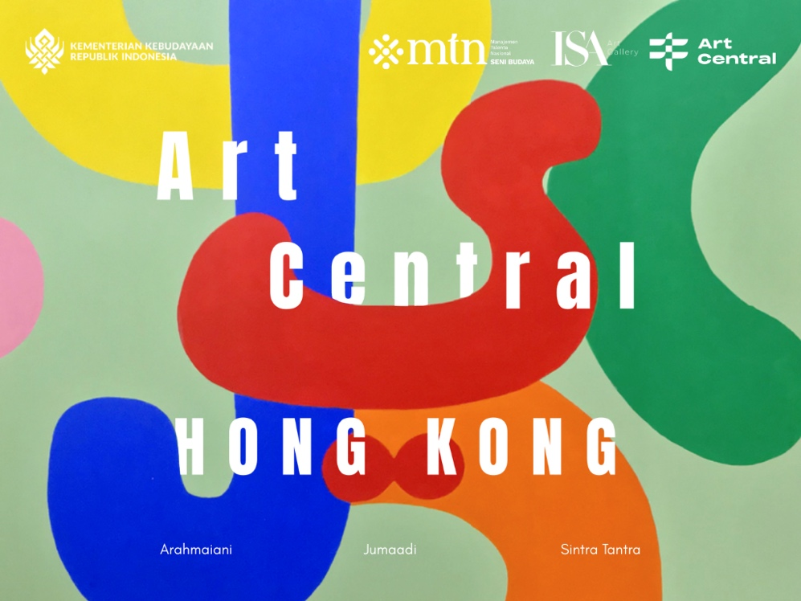

ISA Art Gallery at Art Central Hong Kong

Lines Upon Lines
24 – 29 March 2026
Central Harbourfront
9 Lung Wo Road, Hong Kong

Event schedule
24 March 2026 | VIP Preview, 2 – 8 PM
Wednesday, 25 March | 12 – 5 PM
Thursday, 26 March | 12 – 7 PM
Friday, March | 12 – 7 PM
Saturday, 28 March | 11 AM – 7 PM
Sunday, 29 March | 11 AM – 5 PM

ISA Art Gallery is pleased to announce our latest presentation, Lines Upon Lines, as the Feature Gallery of Art Central Hong Kong 2026. This edition marks an important milestone for the gallery, bringing together three key voices of Indonesian contemporary art at the fair for the first time.

The presentation features works by Arahmaiani, Jumaadi, and Sinta Tantra. Across drawing, painting, and shaped canvas, each artist approaches the line as both visual language and cultural structure, one capable of carrying memory, belief, and movement across time. The relationship between line, movement, and narrative has deep roots in the visual cultures of the Indonesian archipelago.

From the narrative reliefs of temples to the expressive contours of shadow theatre and the symbolic systems embedded in batik textiles, line has long functioned as a medium through which stories, cosmologies, and social values are organised. Lines Upon Lines traces how these visual traditions continue to resonate within contemporary practice, where artists engage inherited forms while responding to the shifting cultural and political realities of the present.

Within this framework, each artist mobilises the line in distinct ways. In the work of Arahmaiani, flowing scripts and gestural marks articulate conviction, spirituality, and social critique. Jumaadi’s drawings unfold as narrative landscapes in which figures, animals, and fragments of memory move across expansive surfaces. Meanwhile, Sinta Tantra’s geometric compositions employ lines to organise space, colour, and perception, creating dynamic structures that invite the viewer into a field of balance and movement. Across these practices, the line becomes more than a formal device: it operates as a connective thread through which histories, identities, and cultural imaginaries continue to evolve.

ISA Art Gallery’s presentation is proudly supported by the Indonesia's National Talent Management for Arts and Culture and the Kementerian Kebudayaan Republik Indonesia, whose support enables the continued international presentation of Indonesian artistic voices.

Arahmaiani (b. 1961)
Arahmaiani stands as one of Indonesia's most influential contemporary artists, internationally recognised for her impactful commentary on social, political, and cultural matters. Emerging as a trailblazer in Southeast Asian performance art in the 1980s, her practice has since spanned media and disciplines. Over the past six years, her work has focused on environmental issues in the Tibetan plateau region, where she collaborates closely with Buddhist monks and local villagers to foster ecological awareness. Her work ‘Burning Country’ was exhibited and collected by Tate Modern London in late 2024.

Jumaadi (b. 1973)
Born in Sidoarjo, East Java, Jumaadi is known for his lyrical drawings and installations that weave together folklore, personal memory, and mythic narrative. His practice often employs materials such as paper, textile, and buffalo hide, referencing the visual traditions of Wayang shadow theatre while developing a contemporary language of storytelling through line. Now based between Yogyakarta and Sydney, his works have been exhibited internationally across Asia, Australia, Europe, and the United States. He has recently unveiled major institutional exhibitions at TANK Shanghai and the Busan Museum of Contemporary Art, further affirming his presence within the global contemporary art landscape.

Sinta Tantra (b. 1979)
Sinta Tantra is known for her bold geometric compositions and large-scale site-responsive installations that extend across architecture, landscape, and public space. Working across painting, sculpture, and public art, her practice explores colour, balance, and spatial perception. Drawing on both modernist abstraction and Southeast Asian visual traditions, Tantra creates immersive environments that engage viewers through rhythm, movement, and the interplay of form and colour. Her work was presented at the 60th Venice Biennale, and she has recently exhibited with Flowers Gallery. Tantra is currently developing a number of forthcoming public art commissions across Europe and Asia, continuing her exploration of painting beyond the confines of the canvas.

For more information about the exhibition and other ISA Art Gallery exhibitions, visit our website at www.isaartanddesign.com or our Instagram page @isaart.id

