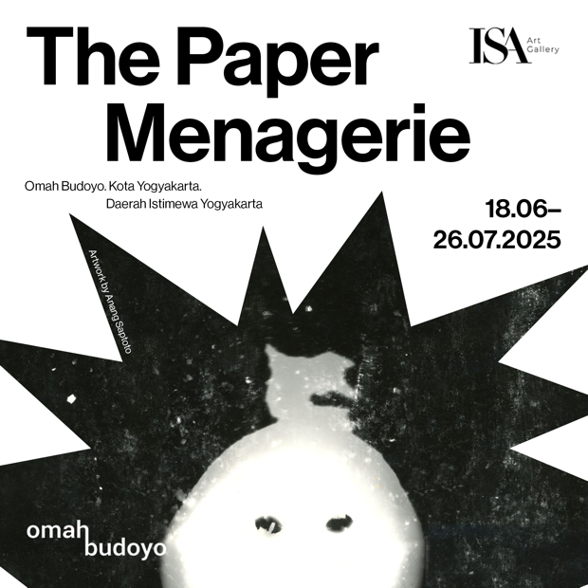

**Date**

18th June – 26th July 2025

**Gallery Opens from**   
10 AM – 6 PM | Closed on Mondays

**Exhibition Opening**

Wednesday, 18th June 2025

At its core, *The Paper Menagerie* Exhibition explores paper’s dual nature—both fragile and enduring, ephemeral yet archival. The first iteration of The Paper Menagerie Exhibition first started at our Gallery in Jakarta and now we are bringing it to Yogyakarta. The exhibition brings together 19 artists, ranging from emerging voices to established figures, who push the boundaries of paper as a medium. Through their works, paper is transformed—cut, folded, sculpted, layered—revealing its potential as a carrier of memory, resistance, and personal history.

Paper has long been an integral part of artistic and cultural expression. Its origins trace back to early Chinese papermaking, evolving across Southeast Asia through materials like *daluang* in Java and *saa* paper in Thailand. Beyond its function as a surface for writing and documentation, paper has historically been used as a medium for storytelling, from Javanese manuscripts to Chinese *Jianzhi* paper-cutting. It has also played a pivotal role in political resistance, from underground pamphlets to protest posters, demonstrating how this seemingly delicate material holds immense power.

This versatility and ability to contain both history and emotion are central to the exhibition, inspired by Ken Liu’s short story *The Paper Menagerie.* In Liu’s narrative, a mother breathes life into paper origami, folding her love into creatures that accompany her son’s journey into adulthood. Yet as he grows, cultural displacement erases their meaning, leaving behind a language he can no longer read, a past he can no longer access. The story’s quiet yet devastating meditation on identity, loss, and remembrance mirrors the nature of paper itself—how it records, absorbs, and preserves, yet can also tear, fade, and be discarded.

Through the works of these 19 artists, *The Paper Menagerie* invites reflection on the ways paper shapes our lives. It is more than just a medium—it is a vessel for stories, a map of emotions, and an archive of fleeting moments. In its folds and fibers, paper holds what might otherwise be lost, waiting to be rediscovered, read, and remembered.

Participating Artists

A.Sebastianus

Adi Sundoro

Anang Saptoto

Ashley Tay

Dara Lo

David Bakti

Egga Jaya

Ella Wijt

HUUH Collective

Jumaadi

Keenan Tham

Mujahidin Nurrahman

Ng Jia Xi

Rui Kai Ho, Ayrton

Ruth Marbun

Sillyndris

Widi Pangestu

Yosefa Aulia

Yunita Rebekah

Zikry Rediansyah

For more information about this exhibition and other exhibitions by ISA Art Gallery, please visit our website at [www.isaartanddesign.com](http://www.isaartanddesign.com) or follow us on Instagram @isaart.id.