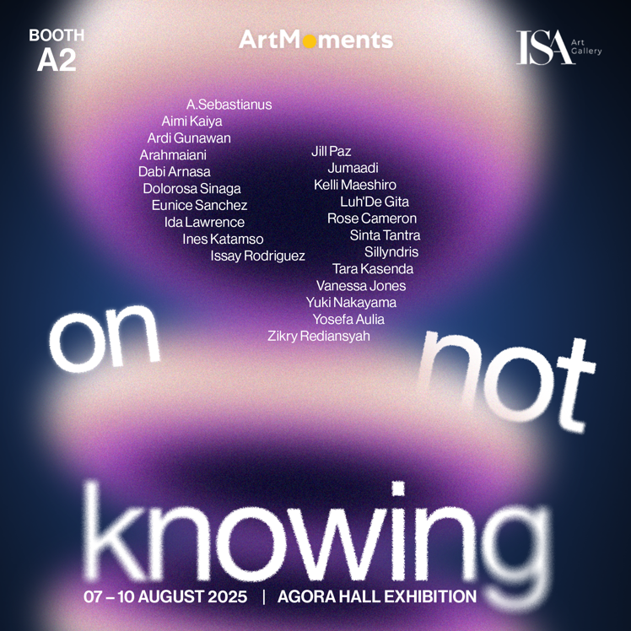

**Date**

**7 August 2025**

Thursday 03:00 PM – 09:00 PM Opening Ceremony

**8 August 2025**

Friday 01:00 PM – 09:00 PM Fair Opens

**9 August 2025**

Saturday 11:00 AM – 09:00 PM Public

**10 August 2025**

Sunday 11:00 AM – 09:00 PM Public

*What does it mean not to know?*

In a world governed by the imperatives of certainty, mastery, and linearity, not knowing is often cast as failure; a lacuna, a weakness, a pause in progress. It is the silence between causes and effects, the hesitation in a sentence that demands closure.

*But what if not knowing is not the absence of meaning, but the seedbed of it?*

For ArtMoments 2025, ISA Art Gallery is proud to present ***On Not Knowing***; a curatorial inquiry into uncertainty, unlearning, and the generative terrain of doubt. Here, not knowing is reimagined

not as a deficit, but as a method, a condition, and a mode of attention. It is an aesthetic strategy, an ethical stance, and an affective state. Rather than to resolve, the works gathered in this presentation is inviting us to misread, contradict, speculate, and enjoy the pleasure of beginning again. Theorists like Emily Ogden (On Not Knowing: How to Love and Other Essays) and Elizabeth Fisher remind us that doubt is not the opposite of knowledge, but a part of its ecology. In a similar spirit, Ursula K. Le Guin’s speculative writing reclaims ambiguity and unknowability as spaces of generative potential; especially for those on the margins of dominant epistemologies.

What if art is not a system of representations to be decoded, but a carrier bag of possibilities? What if meaning does not arrive from clarity, but from dissonance? What if the most radical act today is to pause, to linger, to admit: I do not know? The artists in this exhibition dwell in that uncertain space; in thresholds, digressions, and unfinished thoughts. They resist the institutional pressure toward coherence and instead chart oblique routes: through improvisation, misinterpretation, delay, and rupture.

Participating Artists

A.Sebastianus, Aimi Kaiya, Arahmaiani, Ardi Gunawan, Dabi Arnasa, Dolorosa Sinaga, Eunice Sanchez, Ida Lawrence, Ines Katamso, Issay Rodriguez, Jill Paz, Jumaadi, Kelli Maeshiro, Luh'De Gita, Rose Cameron, Sillyndris, Sinta Tantra, Tara Kasenda, Vanessa Jones, Yosefa Aulia, Yuki Nakayama, Zikry Rediansyah

For more information about this exhibition and other exhibitions by ISA Art Gallery, please visit our website at [www.isaartanddesign.com](http://www.isaartanddesign.com) or follow us on Instagram @isaart.id.